**2015 LFCC Education Consortium**

**Creating Engaging Classroom Settings**

**through Schoolwide Approaches in**

**Secondary Schools**

**June 15, 2015**

Hank Bohanon

hbohano@luc.edu

http://www.hankbohanon.net

https://twitter.com/hbohano

https://www.facebook.com/hank.bohanon

Please feel free to use these materials. Please let me know if they are helpful to you and how you use them to support your efforts.

**I. Introduction to exploring an effective climate in school settings**

**Enduring Understanding:** Be able to identify the components of developing an effective school climate.

**Essential Questions**: How do you organize systems to enhance the support in your environment (e.g., human, financial, structural)?

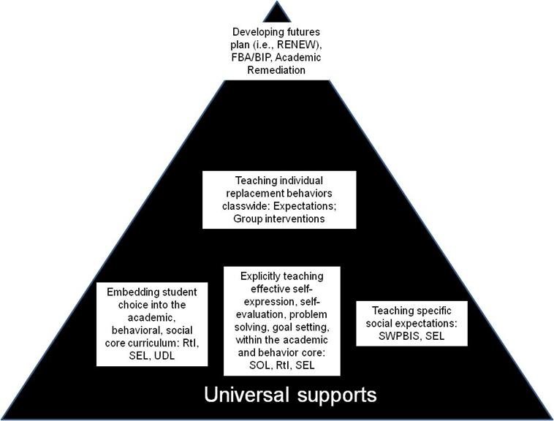

Bohanon, H., Castillo, J., & Afton, M. (2015). Embedding self-determination and futures planning within a schoolwide framework. *Intervention in School and Clinic. 50* (4). Available at <http://ecommons.luc.edu/education_facpubs/16/>

Note. English SOL: 9.1 l) Assume shared responsibility for collaborative work. 10.1 The student will participate in, collaborate in, and report on small-group learning activities. 10.1 e) Demonstrate the ability to work effectively with diverse teams to accomplish a common goal. 10.1 CF Work with peers to set rules for group presentations and discussions, set clear goals and deadlines, and define individual roles as needed. 10.1 The student will participate in, collaborate in, and report on small-group learning activities. 10.1 a) Assume responsibility for specific group tasks, b) Collaborate in the preparation or summary of the group activity. 7.1 c) Make statements to communicate agreement or tactful disagreement with others’ ideas. 10.1 CF Respond thoughtfully by summarizing points of agreement and disagreement, qualifying views and understanding. Virginia College and Career Readiness Performance Expectations: Collaborate with others to exchange ideas, develop new understandings, make

decisions, and solve problems. (SOL 10.1f) (#50)

<http://www.doe.virginia.gov/testing/sol/standards_docs/english/sol_ccss_comparison_english.pdf>

<http://www.doe.virginia.gov/instruction/english/capstone_course/english_core_comparison.pdf>

**Exploring Other Secondary Schools**

**What is working well?**

* District level support in place
* Use of Safe Schools grants to funding coaching
* High levels of implementation
* Office Discipline Referrals are going down in some cases
* Connecting student voice with school climate
* Adjustments to climate based on student input (e.g., facilities)
* Expectations are “branded” in the community
* Great staff, teachers, great students
* Universal supports in place (e.g., expectations and posters)
* Positive discipline model protects student dignity
* Reminders for student expectations in school announcements
* Teaching matrix in place
* Some acknowledgments in place for students
  + Weekly and monthly awards, photo walls of recognized
* Access to schoolwide data system (e.g., SWIS)
* Braiding of RtI and PBIS teams and initiatives
* Connecting Multi-tiered supports with Professional Learning Communities
* Alignment of core curriculum
* Increased student engagement (e.g., belonging, being a part of school)
* Focus on improving effective classroom practices
* Understanding that change in HS takes 3-5 years
* Taking at least a year to plan before roll out
* Building more intensive programs (e.g., secondary, tertiary supports) off of solid core (e.g., universal, schoolwide supports)
* Engaging content and instruction decreases problem behavior
* Teams combing together to support schoolwide efforts
* Leadership teams involve department heads
* Training teachers on practices to support buy-in, before rollout (e.g., teaching expectations)
* Other:

**Next Steps**

* Refresh new teams members on key ideas for tiered systems of support
* Connect tiered systems of support practices with high schools (e.g., need for more examples)
* How to be more proactive in relation to discipline
* How do we go deeper with schoolwide supports in classroom settings?
* Buy-in and ownership for schoolwide supports from staff and students
* What do tiered systems of support look like with a small/large staff?
* How to address behavior from students from dynamic homes/backgrounds (e.g., group homes, conflict, mobility)
* Need for more high school specific acknowledgement practices/examples, from other schools
* Identify and support classroom practices that are effective
* What does acknowledgment look like for high school settings?
* How to develop small starts that lead to effective outcomes
* How to improve climate of the school, this is not a jail?
* How to implement tiers I and II with limited resources (e.g., lack of access to school counselors)
* Organizing supports around tiers II and III, we some have in place, just not organized
* What are the systems around tiers II and III to make them effective?
* What are some useful tier II and III interventions?
* Deciding if student problems are based on “Can’t do” or “Won’t do”
* How to address redirecting the same students multiple times
* How teachers can respond to students with more intensive needs?
* Teachers’ consistency with addressing policies (e.g., cell phone, dress code)
* Getting more students involved in schoolwide supports
* Addressing a need for response to students with intense behavior problems
* How to develop improved rapport with students, particularly students with intense needs
* More supports for addressing tardy to class, disrespect, defiance, electronics, bully behavior
* How to make sure tiered systems of support is not binder on a shelf, just one more thing
* Consistency of the school safety/crisis plan – actual practice
* How do PLC’s connect with tiered systems of support
* How do you connect service learning with tiered systems of support

Other:

Sample Interview Questions for developing buy-in (newer teams)

|  |  |
| --- | --- |
| What is going well in your school around behavior/discipline? |  |
| What are some of the barriers to teaching around discipline? |  |
| What would you like to change about your job AROUND DISCIPLINE? |  |
| Can you say anything about who, when, where, what, and why about problem behaviors and/or desirable behaviors occur in your building? |  |
| What have you liked/disliked about staff development in the past? |  |

Adapted from the work of Jim Knight by Hank Bohanon (hbohano@luc.edu) and the Louisiana PBS Project

Sample Interview Questions for developing buy-in (established teams)

Please answer the questions below about PBIS.

1. What do you like MOST about the implementation of PBIS?

2. What do you like LEAST about the implementation of PBIS?

3. How do you feel the implementation of PBIS could be IMPROVED?

4. How often do you hand out wristbands?

Circle ONE: Never Monthly Weekly

5. What suggestions do you have for reinforcers (rewards) for students? (Think of things

that may or may not cost money).

6. What suggestions do you have for reinforcers for teachers whose names are called

when a wristband is chosen?

Amy Kroll

9-12 Special Education Teacher/Transition Specialist

1829 Central Ave.

Auburn, NE 68305

(402)-274-4328

akroll@esu4.org

**Sample Results**

1. What do you like MOST about the implementation of PBIS?

Have seen an improvement in student behavior (5)

Uniformity and consistency (7)

Get to meet kids they don’t know

Lessons (2)

Kids pick up after themselves

Helps w/social skills

Teaches positive expectations

Wristbands (2)

½ hour of work time for teachers

Awareness of students doing positive things

Discussion of difficult topics with the kids

6-12 Building wide

See same kids every day for set amount of time

Positive behavior enforcement is more effective than negative

Kid’s reaction when name is drawn for wristband

Videos

Clear consequences, good rewards

Working w/students that need extra help

The review of major issues-parking, technology, hallway decorum

No Comment (2)

2. What do you like LEAST about the implementation of PBIS?

Repetition of simple lessons (6)

Lesson effectiveness (2)

Lessons are too elementary (2)

No feedback from teachers

Read-only topics

Wish it could extend to the classroom

Not being visible in other areas than the hall

Teaching partner’s lack of effort and attitude toward students

One partner does all the lessons, work, talking

Filing out the forms, forgetting about doing them (3)

Not having all the materials for the lessons beforehand

Most students have nothing to do (2)

Not everyone rewarding the same things

Students aren’t taking lessons seriously (2)

Rewarding behavior that should be expected from students

Clipboards

The lessons are getting shorter

Students are still treating the positives as jokes

Kids thinking they need a wristband for everything

I like everything about it!

Teachers need to be more consistent

No Comment (1)

3. How do you feel the implementation of PBIS could be IMPROVED?

Use multimedia for lesson presentation

Expand to classroom (4)

Increase rewards

More group activities

More speakers

Change lessons, too repetitive, gear toward high school (2)

Wristband stipulations need to be more clear-teachers are handing out

wristbands for behaviors not on the matrix

Shorter

How we recognize the wristband winners

Everyone following the same rules (2)

More activities to reinforce lessons

ARC Time is too long

Students have lost focus of purpose 2nd semester

More relevant movies on Youtube

Have monthly meetings w/teachers

Keep educating staff about steps to take various situations

Apply consequences withinin one day

No comment (13)

4. How often do you hand out wristbands?

Circle ONE: Never (7)

Weekly (4)

Monthly (18)

Other (3)

Amy Kroll

9-12 Special Education Teacher/Transition Specialist

1829 Central Ave.

Auburn, NE 68305

(402)-274-4328

akroll@esu4.org

**More Self-Assessment Tools**

Behavior See: – <http://www.pbisapps.org> see Self Assessment Survey;

Academic and behavior Self-Assessment for Buy-In (Niles West High School): <https://docs.google.com/spreadsheet/viewform?usp=sharing&formkey=dHFnSWtjRzdiY1k4M0w0b2kxWHMwNVE6MA#gid=0>

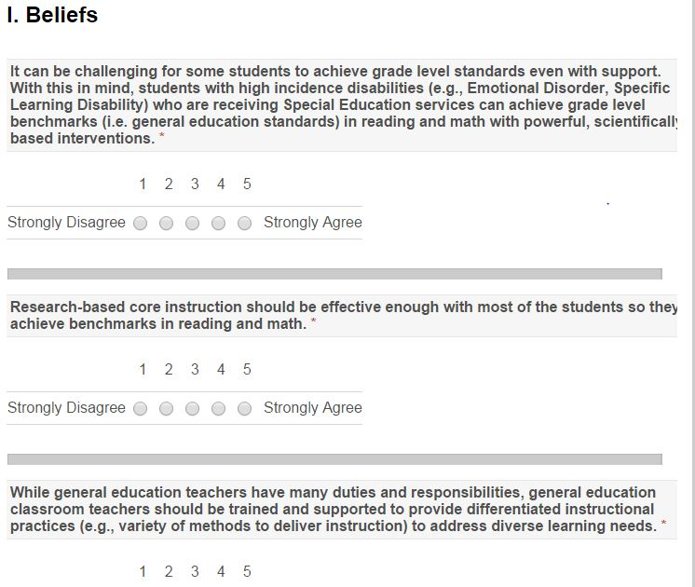

Adapted from http://www.floridarti.usf.edu/resources/program_evaluation/ta_manual_revised2012/index.html - See Tools for Examining Consensus Development

**Activity:** Given these example, what are some ways you can “ask before you tell” to obtain, maintain, or increase buy-in from staff?

Determine your next step.

Based on your team time discussion, list at least 2 action statements.

|  |  |  |
| --- | --- | --- |
| **WHAT NEEDS TO BE COMPLETED?** | **WHO** | **WHEN** |
| A. |  |  |
| B. |  |  |
| C. |  |  |
| D. |  |  |

**II. Work smarter and effective teams in high school settings**

**Enduring Understanding:**  We need each other to accomplish the goal of improving outcomes

**Essential question:** What are effective ways to encourage teams to work together efficiently and effectively?

**Activity:** Use the blank triangle on the following page to complete Activity:

Step 1: Identify all programs/initiatives/common practices by tier

Tier I- How do you support all children? Core Curriculum- “everyone gets”

Tier II, III How do you support students who need more support? How do you build on the foundation so that all Tier II, III activities are a natural extension of core curriculum?

Other considerations:

Can you identify outcome for each practice? How do you measure effectiveness?(Staff performance) How do monitor progress? (student impact) How do you support teachers? (staff support)How are they linked to School Improvement? (integrated approach)

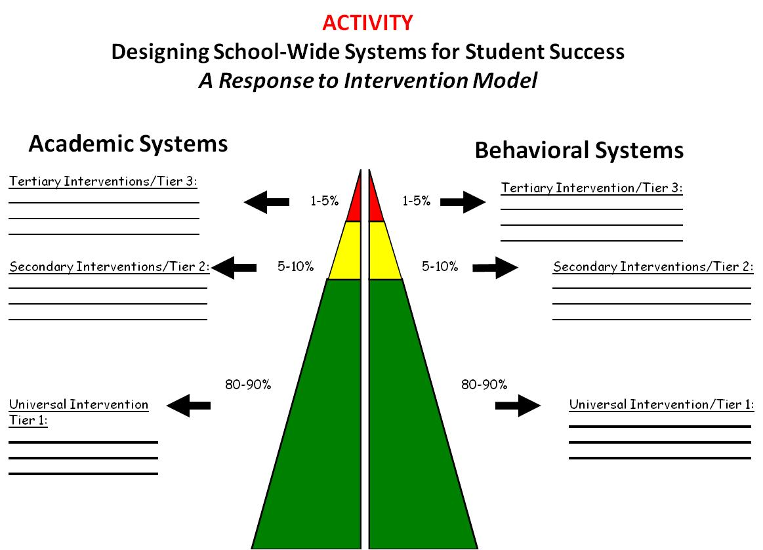



Link to blank file:  [http://69.195.124.205/~hankboha/wp-content/uploads/2014/04/Working_Smarter_Matrix_from_11.07_c](%20http://69.195.124.205/~hankboha/wp-content/uploads/2014/04/Working_Smarter_Matrix_from_11.07_c) Examples below can be found at <http://www.hankbohanon.net> (Resources)





Link to Behavior Education Program: <http://miblsi.cenmi.org/LinkClick.aspx?fileticket=XqRfz3O9AFo%3d&tabid=1855>

**Reflection:** How will you continue to map and organize? How do supports/activities change across the year?

*Consider what communication structures for sharing information and data you have in place now and discuss what opportunities you haven’t explored yet. Record your team’s discussions.*

Determine your next step.

Based on your team time discussion, list at least 2 action statements.

|  |  |  |
| --- | --- | --- |
| **WHAT NEEDS TO BE COMPLETED?** | **WHO** | **WHEN** |
| A. |  |  |
| B. |  |  |
| C. |  |  |
| D. |  |  |

Action Plan Tuesday

Status: C= Complete, I=In progress, N=Not started

|  |  |  |  |
| --- | --- | --- | --- |
| **Task** | **Who** | **When** | Status |
| **Teaching expectations** | Whomever wants to help | At some point | ? |
| **Fix bad behaviors** | Mrs. B. | By tomorrow | Hurry! |

(contact Hank Bohanon [hbohano@luc.edu](mailto:hbohano@luc.edu))

**Bad Meeting Example**

Team Meeting Friday!!!

We will be discussing the following agenda items:

• Problems

• Ideas

Meeting notes from Friday

3:00 – Two team members were present

3:15 – Two present team members realized that time and place had not been announced

3:20 – Announcement made over loudspeaker

3:40 – All 8 team members present

3:45 – Team had an in-depth discussion about the problems with the raffle system. Comments included the following:

Mr. A. and Mr. B. feel that not enough teachers are using the raffle tickets, and that we should track somehow which ones are not.

Ms. C., Mr. D. and Ms. E. all feel that teachers should do this voluntarily and should not be punished for not using it. (This discussion went on until 4:05, with no resolution, when the next issue was raised).

Ms. F. commented that many times the raffles do not happen at all because there is no system for them. Ms. G. and Ms. H. offered the idea of setting up a schedule. The team debated the pros and cons of a schedule. Mr. A feels that a schedule makes things to rigid and is a problem if someone is out sick. Ms. D. agreed. Ms. G. and Ms. H. felt it would be better than the current situation. At 4:30, Ms. H. and Mr. A. began shouting and pointing fingers at each other, at which point Ms. G. and Mr. B. stood up and called for an end to the discussion since the meetings typically end at 4:15 and more business needed to be covered.

4:30 – Mr. B. brought up the issue of having a meeting facilitator. Ms. C. told a story about one staff member who ruined a team by becoming the leader and behaving like a tyrant. Ms. D. told a story similar to that of Ms. C.

4:45 – The team agreed to disagree for the time being and set another meeting for Monday, time and place TBA.

Adapted from reality Kira Hicks, Contact Hank Bohanon [hbohano@luc.edu](mailto:hbohano@luc.edu) or <http://www.hankbohanon.net>

**Reflection Activity**

1. Rate the health of their teams on each item

5 positive things are going great

1 not at all and we need to work on this

• ___Scheduling and communication

• ___Creation and use of an agenda

• ___Meeting begins and ends on-time

• ___Keeping the meeting on track

• ___Action plan/delegating tasks

• ___Meeting Participation

• ___Dissemination of meeting notes

**Meeting Facilitation Rubric**

**Purpose**

The purpose of this tool is to help guide teams in the development of methods and processes for effective team meetings.

**Administration**

This tool is to be administered to teams at school sites that are engaging in the implementation of approaches such as Positive Behavior Support and other three-tiered initiatives.

**Timeline for Administration**

This tool in completed once during the summer or early fall. However it may be administered at anytime in order to assist with action planning.

**Administration Instructions**

This tool is designed to be completed by the entire team based on consensus. For each of the components of team meetings, there are three categories of implementation based on a descriptive rubric. This rubric is designed to help you judge if the premise in the prompt has a status of Exceeding the Standard, Meets Standard, or Does not meet Standard as defined in the top of each page.

|  |  |
| --- | --- |
| **School Name** | **Date of Completion** |
| **District Name & Number** | **County** |

|  |  |  |  |
| --- | --- | --- | --- |
| Category | Exceeds standard | Meets Standard | Does not meet Standard |
| **Scheduling and communication** | Notices are sent no later than two weeks in advance of planned meeting. Notice includes the date, time and purpose of the meeting. Any materials that will be necessary for the meetings are also included Follow-up notices are sent the week of the meeting. | Notices are sent two weeks prior to the meeting. The notice includes the date, time and purpose of the meeting. | Notices are sent a few days before the meeting or not at all.  Meeting notice does not include date, time, location or purpose of the meeting. |
| **Creation and use of an agenda** | Internal leadership independently generates own agenda that is based on the action plan. An agenda is provided for all meeting attendees in advance of the meeting. The agenda includes a section for review of minutes and progress on the action plan from the previous meeting. All relevant topics that will be covered during the meeting are listed. The agenda includes a section for review of current data which are used for next steps. The data are prepared by the internal team. The next meeting is scheduled. | An agenda is provided for all meeting attendees that is based on the action plan. The agenda has a section for covering the minutes from the previous meeting. The agenda incorporates all relevant topics that will be covered during the meeting. The agenda includes a section for review of current data which are used for next steps. The next meeting is scheduled. | There is no agenda, or the agenda does not include minutes from the previous meeting, a list of topics to be covered, or allows time to discuss next steps and schedule the next meeting. |

|  |  |  |  |
| --- | --- | --- | --- |
| Category | Exceeds standard | Meets Standard | Does not meet Standard |
| **Meeting begins and ends on-time** | Attendees arrive before the scheduled meeting time and are prepared to work. The meeting ends at the pre-determined time, or in advance. Facilitator ties the problem solving process to the larger vision and outcomes. | Attendees arrive on time and the meeting ends promptly at the pre-determined time. Facilitator uses a problem solving process to guide the meeting and to handle conflicts. | The attendees arrive late, or not at all. The meeting runs over the allotted time. |
| **Keeping the meeting on track** | The meeting facilitator and the attendees strictly adhere to the agenda. Conversations are limited to discussion of agenda items. Any concerns that are not part of the agenda are noted and are covered in the subsequent meeting. Meeting attendees are respectful of time constraints. Attendees respect the opinions and suggestions of fellow participants. The meeting ends on time with completion of the action plan, delegation of tasks and scheduling of the next meeting. | The meeting facilitator and the attendees follow the agenda and are on track at least 90% of the time. The side conversations do not disrupt the meeting. The participants are respectful of one another. The meeting ends on time with all agenda items covered and the action plan completed. The next meeting is scheduled. | The facilitator and/or the attendees do not adhere to the agenda. There are numerous side conversations that undermine the focus and the tone of the meeting. Individuals freely express concerns that are not part of the agenda. The meeting runs overtime. Participants engage in the following behaviors: monopolizing the meeting, making sarcastic comments about other participants or program initiatives. Agenda items are not covered. The action plan is not completed. The date, time and location of the next meeting are not scheduled. |

|  |  |  |  |
| --- | --- | --- | --- |
| Category | Exceeds standard | Meets Standard | Does not meet Standard |
| **Action plan/delegating tasks** | The action plan is completed at the end of the meeting. Tasks are delegated and incorporated as part of the action plan. The action plan is updated and distributed within two days following the meeting. | The action plan is started during the meeting. Delegation of tasks is determined before the close of the meeting. The action plan is updated and distributed within five days following the meeting. | The action plan is not utilized during the meeting, nor is it updated at the conclusion of the meeting. It is unclear who is assigned to complete tasks. The action plan is not updated and distributed. |
| **Meeting Participation** | All participants regularly attend meetings and are active in developing and carrying out the action plan (e.g., sign up for and complete tasks on the action plan). Team members represent a variety of ethnic and cultural backgrounds and are encouraged to fully participate. Data are integrated into ongoing celebrations and acknowledgments at meetings and throughout the school. | The majority of participants regularly attend meetings and are active in developing and carrying out the action plan (e.g., sign up for and complete tasks on the action plan). Team members represent a variety of ethnic and cultural backgrounds and are encouraged to fully participate. Acknowledgement of participation and completion of tasks occurs regularly. | Participants attend meetings on an inconsistent basis and are not active in developing and carrying out the action plan (e.g., sign up for and complete tasks on the action plan). |
| **Dissemination of meeting notes** | The meeting notes which include the date, time and location of the next meeting are distributed within two days following the meeting. | The meeting notes which include the date, time and location of the next meeting are distributed within five days following the meeting. | The meeting notes are not distributed after the meeting. |

**Action Plan for Updating Team Processes**

|  |  |  |  |
| --- | --- | --- | --- |
| **Activity** | **Activity Task Analysis** | **Who** | **When** |
| **Scheduling and communication** | a. |  |  |
| b. |  |  |
| **Creation and use of an agenda** | a. |  |  |
| b. |  |  |
| **Meeting begins and ends on-time** | a. |  |  |
| b. |  |  |
| **Keeping the meeting on track** | a. |  |  |
| b. |  |  |
| **Action plan/delegating tasks** | a. |  |  |
| b. |  |  |
| **Meeting Participation** | a. |  |  |
| b. |  |  |

V. 1.2 Revised – Pamela Fenning, Jennifer Rose, Kelly Carney, and Hank Bohanon

V.1.3 Revised – Hank Bohanon, 06/28/2010 Loyola University Chicago

V.1.4 Revised – Hank Bohanon, 06/26/2012 Loyola University Chicago

**Activity:** Review “Early Stages for implementation”

Given your current setting –where are you in the Exploration Phase?

What might be some key experiences you can use to bring along your staff?



Link to article <http://ecommons.luc.edu/education_facpubs/17/>

**III. Installation and initial implementation: Using data and preparing for your core**

**Enduring Understanding:** We need to use data to plan for interventions

**Essential Questions:** How can you use data to plan for interventions – at the beginning of the year and on-going? How can teams convert data to a plan of action based on fidelity and outcomes?

|  |  |
| --- | --- |
|  |  |

|  |  |
| --- | --- |
|  |  |

If these were your data, how would you respond?

**IV. Initial Implementation and systematic networking: Practices of an effective universal core curriculum in schools**

**Enduring Understanding:** Be able to identify the components of engaging environments that prevent and address problem behavior for students

**Essential Question:** What are the components of effective school environments? How do these components connect with an effective instructional model?

**Supportive Environments Quiz**

With the following statements, decide who was the possible author (e.g., elementary school administrator, middle teacher, high school teacher, other).

1. We cheer people on all the time..We celebrate everything! Although we do have some formal celebrations, a lot of them are informal, spontaneous celebrations that cost little or no money.
2. We catch people doing things right and accentuate the positive by praising them.
3. [After problem] I watch him or her closely so that, as soon as possible, I can catch the person doing something right.
4. People listen to you because they trust you, not just because of your authority.
5. Culture defines what “Doing the Right Thing” means in a group, it makes dealing with expected behavior “not personal.”
6. Our core values include: Pursue Growth and Learning, Be Passionate and Determined, Be Humble

**LESSON PLAN OVERVIEW**

**BIOLOGY**

**Week of September 1, Periods 1,2,4,5,7**

**By BK**

Themes: Welcome students;

Begin to set climate of class (i.e. a climate of safety and learning);

Introductions and overview of class, expectations and routines;

General introduction to science and to “science in the news”.

**Monday, 9-01**

No School - Labor Day Holiday

**Tuesday, 9-02 (modified schedule)**

1. Welcomes students.

2. Introductions - introduce self ; have students introduce the student next to them by first interviewing him/her (using prompts listed on transparency) and then introducing them to the class. *(transparency: listing interview questions*)

3. Present a general overview of the class. (refer to *transparency*).

4. Explain what supplies students are expected to bring with them daily. *(transparency: listing supplies).*

*5.* Distribute and have students complete the *student profile forms.*

5. Sign programs

{materials: transparencies; student profile form; programs}

**Wednesday, 9-03 (advisory schedule)**

1. Welcome any new students. Sign programs.

2. *Bell ringer*: have students complete a chart *[*refer to *transparency* which lists the 4 school wide areas of expectations: (1) be respectful; (2) be academically engaged; (3) be responsible; and (4) be caring.] Ask students to list the tings they can do to meet each of these areas. Then ask students to list the expectations they will have of me as teacher in each of the areas.

3. Ask students to present their lists and compile one master list for class (on easel paper)

4. Distribute and review list of class rules.

5. If time allows: Prompt students to brainstorm current worldwide science related topics. List on white paper.

Discuss each item with students prompting them to tell everything they know about the topic.

Emphasize how important science is to our every day life.

{materials: transparencies; white easel paper}

**Thursday, 9-04**

1. If # 5 from yesterday was not completed have students make a list of science related news topics as *bell ringer*.

2. Relate to theme of science in the news, show video of various news clips regarding major current science related issues occurring throughout the world. Stop and start video prompting discussion of each topic. Relate to list completed by students.

(*materials: video, vcr, TV, white sheet from yesterday)*

**Friday, 9-05**

1. Distribute Biology pre-test. Explain purpose. Have students take test. {handout pre-test}

**BIOLOGY SYLLABUS**

**Class Taught by Mr. K**

**September,**

**Course Description**

Biology is the study of living things. Scientists estimate that there are more than 12 million different species of organisms living on Earth today. These living organisms range in size from tiny microscopic bacteria to huge blue whales and towering redwood trees. Although they differ greatly in where and how they live, all living things share certain characteristics that make them different from nonliving things. These characteristics include the ability to reproduce, to grow, to develop, to use energy, and to respond and adapt to changes in the environment.

**Course Objectives:**

By the end of the school year you will be able to demonstrate a good understanding of the principles, processes and vocabulary related to the following areas:

1. Important life processes;
2. Scientific inquiry and investigation, including the scientific method;
3. The cell, including cell theory, cycle, structure, processes, growth and division;
4. Biochemistry;
5. Ecology;
6. Energy processes, including photosynthesis, ATP and cellular respiration;
7. DNA and Genetics;
8. Reproduction;
9. Classification;
10. Evolution;
11. Other current science, research and related issues;

**Required Texts, Materials, and Supplies**

Text: BIOLOGY, The Web of Life By Scott, Foresman, Addison Wesley

Materials and Supplies

(1) Notebook (3 ring binder);

(2) Pens, paper, pencils;

(3) Other items supplied by the school, I.e. colored pencils, dividers, markers, construction paper, rulers, microscopes, videos, lab materials and supplies, pictures, newspapers, journals, magazines and other scientific publications

**Class Format**

*Bell ringers *Lecture *Demonstration

*Individual, pair and group work *Reading *Written class assignments

*Note taking *Homework *Lab activities

*Reports (written and oral) *Presentations *Vocabulary work

*Science notebook *Interactive dialogue, discussion, debate

*Tests and quizzes *Research paper *Extra credit assignments

As indicated by the above list, the class format will emphasize and incorporate reading, writing and higher order thinking skills.

**Classroom Rules and Expectations You Will:**

1. Follow the Uniform Discipline Code;

2. Follow the classroom expectations (see attached lists)

3. Maintain good attendance; **[Unexcused absences WILL LOWER YOUR GRADE**]

|  |  |
| --- | --- |
| **# of days absent**  **\*from 9/2/03 to 1/30/04** | **Highest possible grade for**  **Semester One** |
| **Less than 9** | **A** |
| **9** | **B** |
| **10 - 13** | **C** |
| **14 - 17** | **D** |
| **18** | **F** |
| *the same policy applies to Semester 2, just change the | dates from 2/2/04 to 6/22/04 |

**Grades**

**Grades will be determined by the percentage of total points accumulated. Grades will be given as follows:**

90 - 100 A

80 - 89 B

70 - 79 C

60 - 69 D

Below 60 F

|  |  |  |
| --- | --- | --- |
| **Notebook**  **(10% of grade)** | **Performance Points**  **(25% of grade)** | **Academic Points**  **(65% of grade)** |
| Organization of all work | On time for class  Prepared for class | Tests  Quizzes |
| Neatness of papers | Behavior | Activities and projects |
| Ownership of notebook:  Evidence of individuality | Participating in class discussions and assignments | Class work and homework |

* There will be no exceptions to the grading policy. Tardiness, cutting and inappropriate behavior will have a big effect on your grade.

* Chapter tests and quizzes: material will come primarily from assigned readings, lecture notes, lab work, and other assignments as announced.

* Assignments MUST be legible or they will be returned without a grade.

* Semester tests: will be comprehensive.

* Make-up tests: For excused absences only , must be taken within three days of the student’s return to school.

* Late work: Work that is late, due to an excused absence or other approved reason, will be accepted within one week of the due date. Grade may be lowered one step. NOTE: If absent, it is the **student’s responsibility** to find out what he or she has missed .

**\*\*\*\*\*\*\*\*\*\*\*\*\*\*\*\*\*\*\*\*\*\*\*\*\*\*\*\*\*\*\*\*\*\*\*\*\*\*\*\*\*\*\*\*\*\*\*\*\*\*\*\*\*\*\*\*\*\*\*\*\*\*\*\*\*\*\*\*\*\*\*\*\*\*\*\*\*\*\*\*\*\*\*\*\***

I have read the syllabus for Mr. K’s class. I understand the content of the syllabus and agree to abide by the rules, expectations and other items outlined in it.

______________________________ ______________ _______

Signature Date Period

**CLASS EXPECTATIONS**

**As prepared and listed by students on in**

**Mr. K’s BIOLOGY CLASSES**

**\*\*\*\*\*\*\*\*\*\*\*\*\*\*\*\*\*\*\*\*\*\*\*\*\*\*\*\*\*\*\*\*\*\*\*\*\*\*\*\*\*\*\*\*\*\*\*\*\*\*\*\*\*\*\*\*\*\*\*\*\*\*\*\*\*\*\*\*\*\*\*\*\*\*\*\*\*\*\*\*\*\*\*\*\*\*\*\*\*\*\*\*\*\*\*\*\*\*\*\***

**RESPECT**

TREAT OTHERS THE WAY YOU WANT TO BE TREATED

Be polite to each other:

Don’t maker fun of other people

Listen to others

Respect other people’s opinions Respect other people’s belongings Don’t interrupt others Enter and leave the room without pushing or yelling

Raise your hand before talking

Follow rules

Do not disturb the class

Use proper language - No profanity - It’s not just what you say but how you say it (tone of voice, inflection)

No rude nonverbal body language - I.e. rolling eyes; slouching; loud sighing

ATTITUDE

**ACADEMICALLY ENGAGED**

COME TO CLASS WITH CONFIDENCE

Work hard

Do your best

Come prepared for class:

Bring assigned completed work

Bring needed supplies

Complete all assignments and do it on time

Be organized

Take notes

Ask questions

Listen

Participate in activities, discussions

Work with and help others

Pay attention

Come on time

Use the library

Discuss and debate

Learn how to communicate

Study

Raise your hand before talking

ATTITUDE

**RESPONSIBILITY**

TAKE RESPONSIBILITY FOR YOUR ACTIONS

Do your best

Show respect to others

Wear ID (visible)

Follow dress standard

Be on time

Listen

Listen before acting

Copy down assignments

Complete assignments

Come prepared for class

Keep track of things

Take care of books, supplies, classroom

Return supplies and other borrowed items

Help others

Attitude

BE HONEST

**TEACHER**

BE A ROLE MODEL - SET A GOOD EXAMPLE  
 Be polite

Be on time

Come prepared with completed lesson plan

Give meaningful work

Respect students

Respect the opinion of students

Be fair to all students

Treat all students equally (don’t play favorites)

Pay attention to students

Make eye contact with students

Listen to students

Listen to suggestions

Help students

Answer questions

Don’t use put downs

Don’t use profanity

Stay calm; don’t yell; control anger

Give advance notice of assignments and tests

Grade papers and tests on time

Grade “right” (fairly)

Watch body language

Maintain a clean classroom

Remember that “things go both ways”

Treat students as young adults

ATTITUDE

**BUILDING EXPECTATIONS**

**Sample Lesson Plan**

**Objective:** Students will be able to identify and demonstrate respectful behaviors in common areas when presented with a role play situation.

**Expectation:** Be Respectful

**Location:**  When talking with adults in hallways, classrooms, and assemblies.

**Activity:** Role play either with students or staff

**Why this is important:** Ask *“Why is being respectful to adults important?”*

(Sample responses include: People treat you the way you treat them, its nice, everyone is happier)

**Negative Example:**

Ask*“What does it look like to be disrespectful to adults?”*

(Sample responses include: yelling back, screaming, cursing, continue to talk)

**Positive Example:**

Ask *“What does it look like to be respectful to adults?”*

(Sample responses include: listening while others talk, using inside voice,

**Practice:**

Students practice negative example first then positive. Tell the students,

Say  *“We are going to practice the wrong and the right way to ___________.” First, you are going to show us what being disrespectful looks like in ______________. Then, we are going to practice it the right way.”*

Say *“Remember not to do anything that will get you sent to the office or sent home. Also, remember when I raise my hand you are to stop what you are doing! When I raise my hand what are you to do?”*

**How will you know they have learned the skill?**

*“OK, great job! We will be looking for these sorts of behaviors in the fall. If you follow these expectations, you will have a much better experience at Senn. Thank you and good night Las Vegas.”*

**Next Steps:** Practice or discuss other situations *“what should you do if asked for your ID in the hall?”*

**BUILDING EXPECTATIONS**

**Sample Lesson Plan**

**Objective:**

**Expectation:**

**Location:**

**Activity:**

**Why this is important:**

**Negative Example:**

**Positive Example:**

**Practice:** Students practice negative example first then positive. Tell the students, “Remember not to do anything that will get you sent to the office. Also, remember when I raise my hand you are to stop what you are doing! When I raise my hand what are you to do?”

**How will you know they have learned the skill?**

(short term and long term)?

**Next Steps:**

**Checklist for teaching expectations**

|  |  |
| --- | --- |
| **Activity for teaching ___________**  **(list the expectation being taught)** | **Yes= 2 Good Start = 1 No = 0**  **Comment for additional practice** |
| Was the schoolwide expectation explicitly stated? |  |
| Was the location where the behavior is to be carried out identified? |  |
| Was the teaching method clear (e.g. discussion, role play) |  |
| Was a prompt given to discuss why this expectation was important? |  |
| Were students asked for negative examples of the expectation? |  |
| Were students asked for positive examples of the expectation? |  |
| Were the students allowed practice the negative, then the positive behavior? |  |
| Did the teacher pre-teach prompts (e.g., when I raise my hand, stop yelling), to stop inappropriate role play (e.g., show what … does not look like) and were limits of behavior set? |  |
| Did the teacher pre-teach limits for the negative role play (e.g., remember not to do anything that will get your thrown out of class)? |  |
| Were the students provided with feedback about their performance and perhaps additional practice in another situation? |  |

**Total Points:_____________________ Teacher’s Name:________________**

**Percentage:______________________ PBS Consultant:________________**

**Teacher has reached a proficiency level of 90% or better ____________**

**Yes/No**

**Speaking and Listening Common Core**

Comprehension and Collaboration

SL.K.1. Participate in collaborative conversations with diverse partners about kindergarten topics and texts with peers and adults in small and larger groups.

**Follow agreed-upon rules for discussions (e.g., listening to others and taking turns speaking about the topics and texts under discussion).**

**Continue a conversation through multiple exchanges**.

SL.K.2. Confirm understanding of a text read aloud or information presented orally or through other media by asking and answering questions about key details and requesting clarification if something is not understood.

**SL.K.3. Ask and answer questions in order to seek help, get information, or clarify something that is not understood.**

Presentation of Knowledge and Ideas

SL.K.4. Describe familiar people, places, things, and events and, with prompting and support, provide additional detail.

SL.K.5. Add drawings or other visual displays to descriptions as desired to provide additional detail.

**SL.K.6. Speak audibly and express thoughts, feelings, and ideas clearly**

**Example Matrix:** First Day of School Laptop Roll Out and PBiS Lessons for Computer and Technology For Grades 7-12

|  |  |  |  |
| --- | --- | --- | --- |
| ***Laptops/Desktops*** | | | |
| ***SAFE*** | ***RESPECTFUL*** | ***RESPONSIBLE*** | ***STAFF*** |
| * Carry laptop with cover closed * Use a padded carrying case to take the laptop home * No food or drink | * Check out the laptop so others know you have it * Stay only in your files keeping others’ files safe * Hard drive passwords are off limits | * Keep backgrounds, screensavers, or any settings in original settings * If there is a problem with laptop report it * Personal laptops used only with permission | * Monitor, supervise, and teach appropriate behavior and safety |

Expectations of laptop care were reviewed with technology coordinator and superintendent on the first of school. Grades 7-12 were accompanied by their sponsors at different stations that covered internet, cellphone, and technology safety expectations. All staff was involved in teaching the internet safety lessons.

|  |  |  |  |  |  |
| --- | --- | --- | --- | --- | --- |
|  | Laptop Checkout | Oops I broadcast it over the Internet…. | Overexposed | College Bound | Private Today, Public Tomorrow |
| 10:00 to 10:20 | 11th-12th Gr | 9th-10th Gr | 7th-8th Gr |  |  |
| 10:25 to 10:45 |  | 11th-12th Gr | 9th-10th Gr | 7th-8th Gr |  |
| 10:50 to 11:10 |  |  | 11th-12th Gr | 9th-10th Gr | 7th-8th Gr |

Ona Ebsen

School Counselor

West Boyd Public School

www.westboyd.com

Spencer, NE 68777

402.589.1333

Fax: 402.589.1142

**Example lesson/song for locker cleaning:** This is an Alert Now Message from West Boyd Public School. Please listen carefully for the instructions….

Deep In Your Locker

Deep in your locker, what is that smell?

Oh my gosh, -can you tell?

Maybe a t-shirt with lots of sweat

Sneakers or dirty socks I bet.

Ho, ho, ho, who wouldn’t go?

Ho, ho, ho, who wouldn’t go?

Deep in your locker, pitch and throw

All that trash just has to go.

First goes the notes you never took

Found an overdue library book

Get that food and pop bottles out

We’ll give you a slushy so you don’t pout

Ho, Ho, Ho, who wouldn’t go

Ho, Ho, Ho, who wouldn’t go

Make sure you take home all your junk

Start the year off with a nice clean bunk.

Now that your locker is empty too

Get germ wipes and make it new

Set your books up -nice and neat

Then next year you’ll get your treat.

Ho, ho. Ho, who wouldn’t go

Ho, Ho, Ho who wouldn’t go

Deep in your locker, Make it Quick

When you come back -a slushie -from Mary & St Nick.

So here’s the deal….

Clean your lockers and locker room

And we will all enjoy a slushy when we come back after Christmas.

Thanks…..

Ona Ebsen

School Counselor

West Boyd Public School

www.westboyd.com

Spencer, NE 68777

402.589.1333

**Student Engagement: Two ways to increase student engagement**

# (by: Hank Bohanon - see hankbohanon.net)

We are looking for ways to make things work together. A great deal of focus in school is on integrating behavior and academic support. One area that naturally bridges both is student engagement or school connection. Researchers have found relationships between academic improvement and student connections (see for really good article on this <http://eric.ed.gov/?id=EJ1007218>).

According to van Uden and colleagues, engaging students is about the relevancy of the content, the way it is delivered, and other overall climate of the class. I came across their study that included the voice of students related to this topic. These were from students at both K-12 and university levels. I thought their insights were very useful.

Two ways create engagement:

1. Simply asking a student about how their day was going was a very effective approach to engagement. One student said the teacher only had to say a few works, but they felt like the teacher cared and understood them..which was motivating..

1. Asking if you can help and give feedback. Several students said that just asking if they needed help or providing feedback about performance was “support.”

Two ways to create disengagement:

1. Asking detailed questions about the students’ life was not engaging. Many of the students said they did not want to be friends with their teachers. They just wanted the teacher to understand their perspective and if they were going through something that might require some accommodation. I once heard a teacher talk about sharing her early drug use with her students as a way to connect (not how she recovered from this), not a good plan…too much information (TMI) is not good for anyone..

1. Just handing out the work was disengaging. The students said a real turn off occurred when teachers just handed out the work without really covering it (e.g., describing, modeling). See Ferris Buellers Day Offfor more details on how to create disengagement (<https://www.youtube.com/watch?v=uhiCFdWeQfA>)

Charge and question  
To these students, engagement was not about therapy (although there is a place for therapy). It was about taking short amounts of time to ask how they are doing and asking if they needed help. There is certainly more to engagement, but this is a very efficient approach. This article if full of great quotes from students and discussion points. I would recommend it for a professional learning community or other book club. What examples you have seen of engaging students in really simple ways? The article should be available at:<http://www.sciencedirect.com/science/article/pii/S0742051X13001352>

**Student Engagement**

Very good resource for research around literacy and student engagement (Click on Icon)



**Also…**



# Learning Together About Engaging Text Discussion

**Purpose** Trainers, coaches, and expert teachers are encouraged to use this tool to provide in-service training on facilitating text discussion. During this session, teachers will work in the larger group and in small groups to deepen their understanding of instructional strategies and practices.

**Materials** Laptop and projector

**Media** [*Talking About Text: Discussion-Based Approaches to Reading Instruction*](http://wested.mediacore.tv/media/talking-about-text-discussion-based-approaches-to)*.* Watch this multimedia presentation to learn about important features of extended discussions about text. (5:51)  
  
[*Engaging Adolescents in Discussions About Text*](http://wested.mediacore.tv/media/engaging-adolescents-in-discussions-about-text)*.* Watch this expert interview with Dr. Janice Dole to learn about how teachers can use engaging text discussion to facilitate reading comprehension. (5:28)

Topic Adolescent Literacy

Practice Engaging Text Discussion

## Learning Together About Engaging Text Discussion

1. Watch the multimedia presentation, *Using Text Discussions to Engage Students and Improve Comprehension* and the expert interview, *Engaging Adolescents in Discussions About Text*. Lead a discussion to clarify the team’s understanding about engaging text discussions. Ask them to reflect on these questions:
   * Why is it important to provide opportunities for adolescents to discuss text?
   * What are some key features of effective, extended discussions?
   * What should teachers consider when selecting a text for a discussion?
   * What are some of the roadblocks to implementing this practice? What are some ways to address these roadblocks in your classroom?
   * What kinds of tools, materials, or training would you need to incorporate more text discussion into your classroom?
2. Discuss as a group: What can teachers do to create a classroom environment that supports classroom discussion?  
     
   Option: Teachers may discuss the question in small groups and draw a visual diagram of a classroom environment that supports discussion.   
     
   Whole group or small group discussion topics may include the following:
   * Posing authentic and provocative questions for discussion
   * Establishing classroom norms for discussions
   * Creating a safe space for practicing speaking and listening
   * Modeling and practicing discussion roles
   * Providing prompts for participation (e.g., sentence starters)
   * Providing tools to organize discussions (e.g., graphic organizers)
   * Discussion aids posted on classroom walls
   * Physical set-up of classroom
3. Fishbowl exercise:   
     
   To the trainer: Bring in a short text and provocative discussion question for a fishbowl exercise. A group of 5 or 6 teachers is seated in a circle in the middle of the room, surrounded by observers. The group in the center is asked to read the text and respond to the question. The observing group takes notes.  
     
   Option: You may take this as an opportunity to try out an activity structure like reciprocal teaching or literature circles, or simply have a free-form discussion.  
     
   Lead a discussion after the fishbowl activity about what was observed. The questions below can serve as prompts for observers’ note-taking during the discussion or for the debrief after the discussion:
   * What did you notice about body language and non-verbal behavior?
   * What did you notice about how people expressed an opinion?
   * What did you notice about the language or manner with which people agreed or disagreed?
   * (If using roles) What did you notice about how each person carried out their role?
   * How effective were the text selection and discussion question?
   * What skills or strategies did you notice the teachers using that your students haven’t mastered yet?

As a wrap-up, have teachers discuss how they might conduct a fishbowl activity in their own classrooms and how they would modify the activity for their own use.

**Acknowledging Students for Good Behaviors**

* Try to use a 4 to 1 ratio of positive to corrective comments in the classroom
* Be specific : “Thank you for being respectful and handing me your ID when I asked for it”
* Recognize students immediately after a good behavior
* Be genuine: Convey sincerity with tone of voice and body language, message, and choice of behavior to acknowledge (avoid patronizing students)
* Use vicarious reinforcement: acknowledge a student who is meeting your expectation when others are not: “I really appreciate how productive group one is being right now, you all have your books open and are taking notes”
* Make the activity relevant: If the content of an academic activity is meaningful and interesting for students, it is rewarding for them to behave well and participate. For example, for math class, allowing them to complete word problems to figure out how to save money for a video game system (Xbox, Playstation, etc.)

**Pop quiz**: What do you have available to you that would help you reinforce students in a specific, immediate, genuine way? (Hint: Think School Store)

Types of acknowledgement:

Immediate/Frequent:

Intermediate (weekly?) – homework example

Large scale, school sprit oriented (school picnic?)

|  |  |  |
| --- | --- | --- |
| **snapshot.GIF Snapshot: Continuum of Strategies to**  **Encourage Appropriate Behavior**  **Benchmarks of Quality 25-32** | | |
| *Practice: Behavior Specific Praise Statements (BSPS) Ratio 4:1* | | |
| ***Research*:**  The research supports the use of behavior specific praise statements to:   * teach new behaviors and support maintenance of acquired behaviors (Mesa, Lewis-Palmer, & Reinke, 2005) * to increase on-task behavior (Fullerton, Conroy, & Correa, 2009) * to decrease problem behavior (Hawkins, & Heflin, 2010; Lampi, Fenty, & Beaunae, 2005; Lane, Kalberg, Bruhn, Mahoney, & Driscoll, 2008; Mesa, Lewis-Palmer, & Reinke, 2005; Stormont, Covington Smith, & Lewis, 2007; Sutherland, Wehby, & Copeland, 2000) * provide increased opportunities for building positive relationships with students * provide support to students with the most challenging behavior, needing targeted and/or intensive supports, through more frequent behavior specific praise statements delivered contingently for appropriate behavior coupled with less frequent reprimands for inappropriate behavior. Students with the most challenging behavior typically do not receive access to even the average rates of praise that students without challenging behavior receive (Lewis, Hudson, Richter, & Johnson, 2004) | | |
| ***What is it?***  A behavior specific praise statement is verbal/written feedback that is *descriptive*, *specific*, and delivered *contingent* upon student demonstration of expected behavior (Gable, Hester, Rock, & Hughes, 2009; Hawkins & Hefflin, 2010) | ***Effective Praise***   * “Excellent job listening and following directions the first time.” * “Your eyes are on me and your mouth is quiet. Thank you for being ready to learn.” * "Way to go! You asked for help and followed the steps to complete your math work before the end of class!” * "Thank you for being on time this morning, that's very responsible." | ***Less Effective***   * "Good job!" * "Excellent!" * "Well done!"   (Gable, Hester, Rock, & Hughes, 2009) |
| ***Practice***   * Develop classroom rules aligned with school-wide expectations * Post and teach classroom rules * Use 2-3 words from the defined classroom rules to formulate BSPS. * Deliver BSPS immediately after students demonstrate expected behavior. * Use prompts to remind you to use BSPS (e.g. notes to self, tally marks, paper clips from one pocket to another, write BSPS on sticky notes to distribute during instruction.   (Conroy & Correa, 2009; Sprick, Knight, Reinke, McKale, 2006)   * Note: Praise alone may not be powerful enough to change the behavior of some students and more concrete or tangible reinforcers may need to be paired with praise. * Note: Deliver in close proximity in a way acceptable to the student (Gable, Hester, Rock, & Hughes, 2009 ) | ***Observation and Feedback***  *Instructions:*  Conduct a 10-20 minute observation to calculate the frequency and ratio of positive feedback statements (BSPS) to negative feedback statements. Complete a frequency count to record the number of times within the 10-20 minutes that the identified strategy is observed. This can be used as a self-assessment (e.g., recording), a tool for a peer observation, walkthrough, etc. Consider graphing progess.   |  |  |  | | --- | --- | --- | | *Date:* |  |  | | *Strategy: Positive Feedback Ratio 4:1* | *Frequency* | *Comments* | | *Specific, positive feedback (BSPS)* |  |  | | *Negative feedback* |  |  | | Ratio of specific, positive feedback to negative feedback  Positive : Negative Ratio = | | | | Measureable Goal: | | | | |

From Susan Barrett, PBIS TA Center

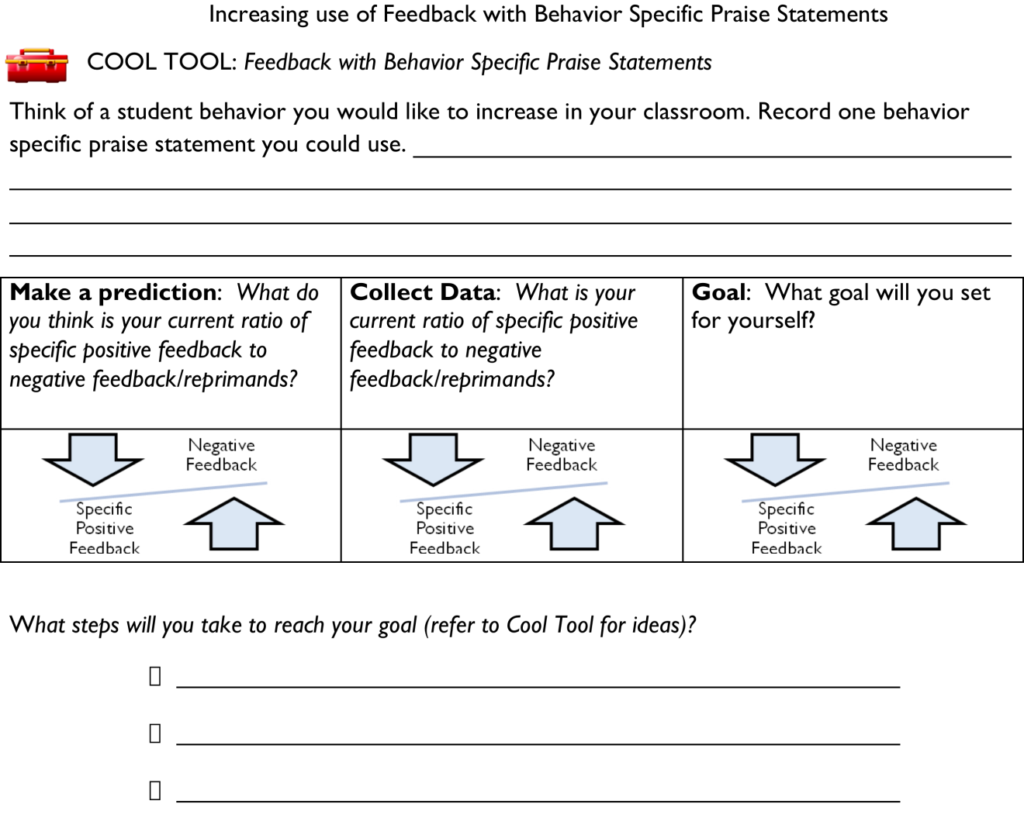

From Susan Barrett, PBIS TA Center

Reinforcement Planning Matrix

|  |  |  |  |  |  |
| --- | --- | --- | --- | --- | --- |
| TYPE | WHAT IT IS | **WHEN WILL IT HAPPEN** | **WHERE CAN/WILL IT HAPPEN** | **WHO WILL BE IMPLEMENTING** | **NOTES** |
| **High Frequency “GOTCHAS”** |  |  |  |  |  |
| Unpredictable/Intermittent “BOOSTERS” |  |  |  |  |  |
| Attention Grabbing “Celebrations” |  |  |  |  |  |

Based on the work of Steve Romano

Link to Sample Acknowledgment Matrix: <http://hankbohanon.net/userfiles/High_School_PBS/Presentations/Acknowledgement/Sample%20school-wide%20reinforcement%20plan%20PD%20OBJ4%20.doc>

**Professional Development on Redirection**

* Think off a student who is off task
  + What might they be doing that is okay?
  + If a student was in a white shirt but did not have out an ID, what could you say first before asking about the ID?
* When stopping a student in the hall, what happens when you don’t use the techniques below?
  + **Use privacy, eye contact, and proximity** when correcting
  + **Start with something positive** – what are they doing right? Or what is the student next to him doing that is right? Praise that behavior specifically.
  + **Assume the student did not know the expectation** (assume innocence until proven guilty)
  + **Use humor** – this is not sarcasm (e.g., you know, some times my arms just fly around too, are you OK now? – Is this really being safe in the hall?)
  + **Stay out of content** when you ask for something or give a direction. When the students says “why” or “who are you” then simply wait a moment and repeat the direction. You must be willing to wait it out, if not, do not use this!
  + **End with a teachable moment**, “Was that an example of being safe?” “What did you need to do instead?”
* When attempting to redirect groups, have you tried the following?
  + **Acknowledge those who are on task**. When the rest come back, thank them. The same can be done for individual students: look for anything they are doing right, and point that out. When they stop problem behavior, thank them for their self-control without having to be told (Hint: Start with something positive).
  + **Stop, wait** for instructional control, **remind and re-teach** expectations.

**Year at a Glance for PBS (**See <http://hankbohanon.net> for Word Doc**)**

|  |  |
| --- | --- |
| **Summer Vacation** | Training and planning with PBS Team  (Typically three meetings)  Develop guidebook for teachers |
| **August** | Develop action plan for first few months of school (Add to this at each meeting throughout the year)  (Be ready for orientations, guidebook, tickets, store, raffles, data, meetings) |
| **September** | Kickoff for school year: Teach expectations, explain the acknowledgement system to all students and staff.  Pass out guidebook and explain (include policy)  Distribute tickets to all staff members.  Begin to look at target level supports: identify groups  Team meets bi-monthly – review data |
| **October** | School store up and running, consistent raffle drawings.  Prepare for secondary supports, identify needs and data.  Feedback from staff about project  Recruit and orient new team members  Review Team Implementation Checklist  Share data with the staff  Team meets bi-monthly – review data |
| **November** | Begin planning first school-wide celebration  Review data, identify secondary needs  Parent climate survey  Team meets bi-monthly – review data |
| **December** | Possible target month: school-wide celebration, encourage acknowledgment system  Secondary supports – on-going  Review Team Implementation Checklist  Share data with the staff  Team meets bi-monthly – review data |
| **January** | Refresh everyone on school-wide system.  Administer SET  Team meets bi-monthly – review data |
| **February** | Feedback from staff about project and present data |
| **March** | Possible target month: school-wide celebration(?), encourage acknowledgment system  Review Team Implementation Checklist  Share data with the staff  Administer EBS  Team meets bi-monthly – review data |
| **April** | Possible target month: school-wide celebration(?), encourage acknowledgment system  Planning retreat for next steps (all day)  Team meets bi-monthly – review data |
| **May** | Administer Climate survey  School-wide celebration (?)  Team meets bi-monthly – review data |
| **June** | Report summary data to staff and feedback  Review Team Implementation Checklist  Set dates for summer planning/training  Final planning meeting  Team meets bi-monthly – review data |

**SWE Rotational Sessions- Staff Development**

**45 Minutes Each**

1. **Rationale: Who will do overview -** 
   1. Why SWE -
      1. Read through the rationale, make it a point to emphasize the EVERYONE when feeling comfortable, valued and welcome
      2. Review the CIWP goal
      3. SWE is not a closed door committee, it is an always accepting, open team

iv.Get back instructional time, fewer power struggles, adds to more comfortable

and productive classroom environment

v. Data: SET (what you are doing), TIC (team’s perception), SAS (teacher

perception) Highlights from office discipline referrals, Goal 50% reductions in the number of classrooms and teachers with 10 or more referrals, general

reduction in classroom ODRs: Slides: Total ODRs, Triangle, By Class, By Month, By Locations, By Who is involved, By Major and by Minor, By Time

of Day, By Teacher response, By Admin, and Suspensions.

1. **Communication -**

a. Walk through the teacher handbook

b. Overview of committees and their major tasks for the year (year at a glance) based on

our priorities from the Effective Behavior Support Survey (EBS)

1. **Data -** 
   1. Show one page from the EBS from the school wide - (pull graph)
   2. Working together to create one clear set of policies
      1. What did we do on the area of communication from the action plan in the following areas. We want you to help with as much as possible:
         1. Hallway behaviors – transition plans TBA
         2. Overview of rotational meeting for students (short overview)
         3. Consequences for major behaviors or repeat problems (in school problem solving is coming): a. check in and check out as needed, office vs class, procedural flow chart, ODR form (how and when to use - see example and why),
         4. redirection strategies (one pager -in handbook) <http://69.195.124.205/~hankboha/wp-content/uploads/2014/04/Handout-on-Redirection7-13-07-Shorter.doc>
         5. Good example of how to stay out of a power struggle video - see about 6 minutes in - maybe use maybe not <http://vimeo.com/groups/pbisvideos/videos/14818677>
   3. Create an **open** line of communication between all staff (survey is coming - welcome to share with team at any point)
2. **Teaching -** 
   1. Role play teaching example and give example - show clip of teacher teaching expectation (short) .
   2. Great example of teaching expectations - maybe use - maybe not - about 2 Minutes into video <http://vimeo.com/groups/pbisvideos/videos/14818677>
   3. Discuss lesson plans for first two weeks
   4. Boosters and on-going teaching – focus on (PUT THE MONTHS IN HERE FOR RE-Teaching AND BOOSTERS BASED ON MONTHLY GRAPH)
3. **Incentives and Acknowledgements -** 
   1. The intent of this team is to encourage and recognize desired positive behaviors
   2. How to acknowledge (see one pager - in handbook) <http://69.195.124.205/~hankboha/wp-content/uploads/2014/04/Acknowledging-One-Pager.doc>
   3. Staff will be encouraged to establish their own “best” methods of recognizing and acknowledging their students that best fit their own classroom management and organizational styles and needs.
   4. High frequency **School Store System**- stickers and school store - how this works **(See TMMS Acknowledgement Grid)**
   5. **Small Group Awards - Checking for appropriate language, Honor roll, Disrespect Checks, and Acknowledging Teacher (See TMMS Acknowledgement Grid)**
   6. **School Wide Awards:** If the students have over 95% attendance in December they will be rewarded with a school dance on December 21st., 2. If we see a 10% drop in Office Discipline Referrals from February to March we will have a Dance on March 28th. If we see a 10% drop in ODRs from May to June we will have a dance June 14th.**(See TMMS Acknowledgement Grid)**
   7. We are hopeful that we as a school will become more mindful of all of the little (and big) things that are done on a daily basis to help maintain a positive work environment.

How can we enhance the components of an effective school environment?

How do we connect components with effective classroom management?

***List at least 2 Action Steps***

|  |  |  |
| --- | --- | --- |
| **WHAT NEEDS TO BE COMPLETED?** | **WHO** | **WHEN** |
| A. |  |  |
| B. |  |  |
| C. |  |  |
| D. |  |  |

**V. Wrap-up universal core and review**

**Enduring Understanding:** Be able to identify the components of effective learning environments from other schools.

**Essential Questions:** What ways other schools are supporting their students’ learning and behavior across tiers?

**IV. Structured Conversations**

**Structured Conversations**

Schools that are implementing tiered systems of support often have minimal contact with other schools going through the same process. This activity provides the opportunity to talk with members of school teams regarding their experience with the implementation process.

**Directions:** Please walk around the room while the music plays. When the music stops, find a seat at the table nearest you. Please use the questions below to guide your discussions around the specific topic. Feel free to generate your own questions as well- this is a great opportunity to hear specific details from those who are implementing and those trying to implement tiered systems of support. Each specific topic has been allocated 25 minutes for this discussion activity.

|  |  |
| --- | --- |
| **Topic** | **Discussion Questions** |
| Developing Staff “Buy-In” | 1. How has your school’s leadership gathered information on staff concerns about student behavior and implementation questions regarding addressing behavior?    1. How was this information collected? 2. How did you use the information collected from staff to communicate that your team can address the needs of the school? 3. How have you piloted behavior support implementation (e.g., within a specific grade level or within a specific setting) 4. What worked for you in developing staff “buy-in”? (either for PBIS implementation of another initiative) 5. What might you do differently next time to develop staff “buy-in”? (either for PBIS implementation of another initiative) 6. Other questions you might have… |
| Team Development | 1. Does your school’s leadership team represent the constituency of your school (e.g., general education, special education, administration, multiple grade level or content area representation, etc.)? 2. How did your team prepare for working together effectively as a team? (e.g., setting norms, setting goals, communicating a common vision, setting schedule) 3. How does your team use data for decision making? (e.g., student discipline data, implementation data) 4. What is working well for your team? 5. What are your suggestions for improving leadership team development? 6. Other questions you might have… |
| Teaching and Acknowledging Behavior Expectations | 1. How did your school implement teaching of behavior expectations? (when did this take place, who was involved, how was teaching done) 2. How did you prepare staff for the teaching of behavior expectations? (teaching how to teach the expectations, preparing lessons, practice teaching, providing feedback) 3. How do you get students involved in the teaching of expectations process? (student input, feedback on effectiveness, involvement in teaching the expectations to others) 4. How has your school implemented acknowledgement systems for students engaging in behavior expectations? (high frequency systems such as tickets or behavior slips; and/or large scale systems such as public awarded certificates, dances, movie nights, grade level or team group contingencies) 5. How did you prepare staff for the acknowledgement systems? (teaching how to acknowledge, when to acknowledge, how the ticket exchange system works, practice acknowledging with specific praise, providing feedback to those who acknowledge students) 6. How do you get students involved in the acknowledgement process? (student input, feedback on effectiveness, involvement in acknowledging others) 7. Other questions you might have… |
| Student engagement | 1. How do your teachers address student engagement in your school? 2. Which of your schools core/universal instructional practices are related to creating student engagement? 3. How do you know if your students feel connected to your school? 4. How do you support your teachers in creating engaging environments for students? 5. Other questions you might have… |