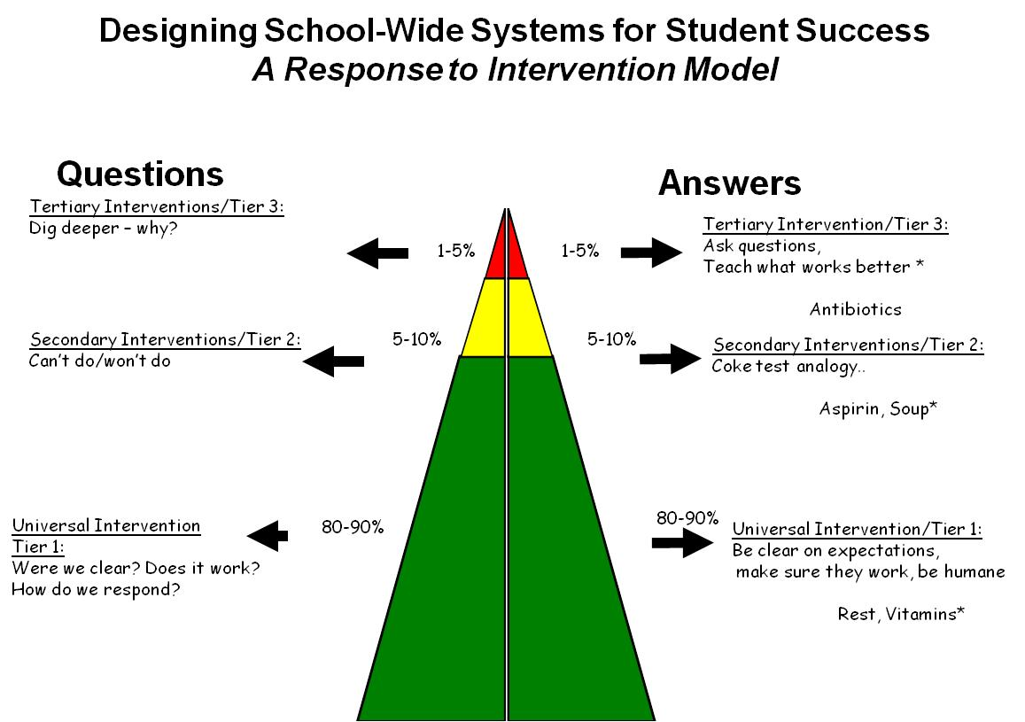

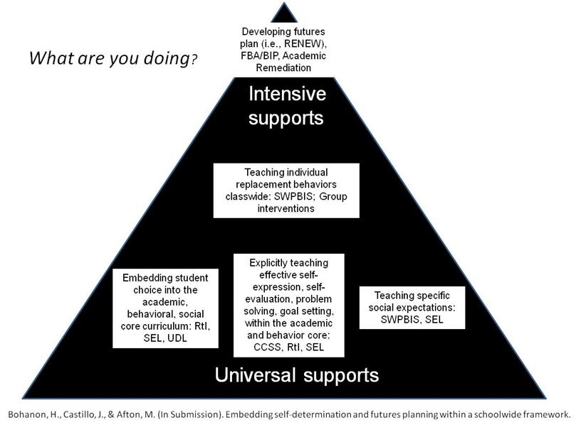

Note. 9th and 10th grade students are expected to express themselves effectively and develop rules for collegial discussions and decision making when working with peers (CCSS.ELA-Literacy.SL.9-10.1 and CCSS.ELA-Literacy.SL.9-10.1b). Learning how to develop and evaluate a plan by gathering information (problem solving) is directly related to standards involving writing (CCSS.ELA-Literacy.WHST.9-10.5 and CCSS.ELA-Literacy.WHST.9-10.8). Skills related to self-advocacy (e.g., making your point effectively) are related to anchor standards for college readiness (CCSS.ELA-Literacy.CCRA.SL.1and CCSS.ELA-Literacy.CCRA.SL.4.). Addressing the key standards may be one effective way to encourage participation in self-determination supports.

What works with EBPS

See the components of evidenced-based practices
What Works with EBPs; Foreman, Olin, Hoagwood, Crowe, and Saka, 2009)
- the development of support from the administration (e.g., principal);
- obtaining support from teachers (e.g., priority);
- obtaining financial resources to sustain the project (e.g., FTE);
- providing effective training and coaching to increase fidelity;
- the alignment of the interventions with the schools’ goals, philosophy, policies, and programs (e.g., PLC);
- making sure program outcomes are visible to all stakeholders (e.g., share data); and
- developing processes to address the change in staff and administrators (e.g., plan, manual, specified roles).

Reflective question: Can you think of times when these were applied with success? Or perhaps non-examples?

